**Project Design Phase**

**Solution Architecture**

|  |  |
| --- | --- |
| Date | 29 june 2025 |
| Team ID | LTVIP2025TMID50169 |
| Project Name | iRevolution A Data-driven Exploration of Apple's iPhone Impact in India using Tableau |
| Maximum Marks | 4 Marks |

**Solution Architecture:**

Solution architecture is a complex process – with many sub-processes – that bridges the gap between business problems and technology solutions. Its goals are to:

* Find the best tech solution to solve existing business problems.
* Describe the structure, characteristics, behavior, and other aspects of the software to project stakeholders.
* Define features, development phases, and solution requirements.
* Provide specifications according to which the solution is defined, managed, and delivered.

**Example - Solution Architecture Diagram:**

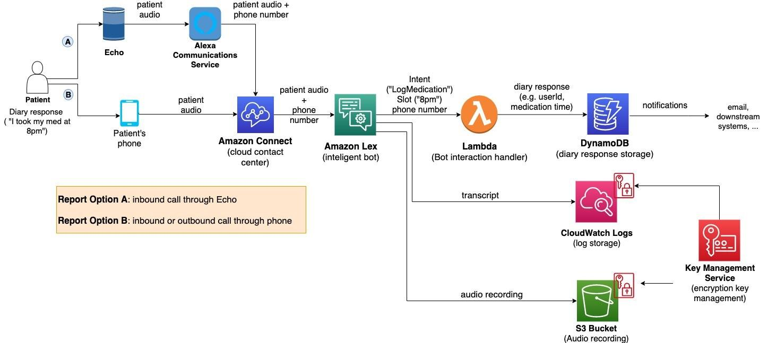

*Figure 1: Architecture and data flow of the voice patient diary sample application*

**Reference:** [**https://aws.amazon.com/blogs/industries/voice-applications-in-clinical-research-powered-by-ai-on-aws-part-1-architecture-and-design-considerations/**](https://aws.amazon.com/blogs/industries/voice-applications-in-clinical-research-powered-by-ai-on-aws-part-1-architecture-and-design-considerations/)

**🔍 Goals:**

* **Solve the problem of low transparency in iPhone pricing, reviews, and feature comparisons in India.**
* **Offer an interactive dashboard using Tableau to visualize real-time and historical iPhone trends.**
* **Enable consumer decision-making and business intelligence for marketers/resellers.**

### ⚙️****Technical Components****

| **Layer** | **Tools & Tech** | **Description** |
| --- | --- | --- |
| Data Source | Flipkart, Apple Reports | Primary data on iPhone models, ratings, and pricing |
| Data Cleaning | Python, Excel | Handling nulls, formatting, merging |
| Storage | CSV, Excel, or Cloud DB | Pre-processed data ready for Tableau |
| Visualization | Tableau | Interactive dashboards with filters, trend lines, heatmaps |
| Access | Web/Local Tableau | Used by teams, customers, and analysts |

**🚧 Development Phases**

| **Phase** |  | **Task** |
| --- | --- | --- |
| **Phase 1** |  | **Data collection and formatting (Excel/CSV)** |
| **Phase 2** |  | **Dashboard prototype with 2–3 key KPIs** |
| **Phase 3** |  | **Add interactivity: filters, dropdowns, regional insights** |
| **Phase 4** |  | **User testing and business feedback** |
| **Phase 5** |  | **Final deployment and documentation** |